**Lab 2**

Q1:

Q2:  
Q3:

  
Q4:   
Q5:  
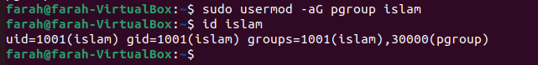

Q6:  
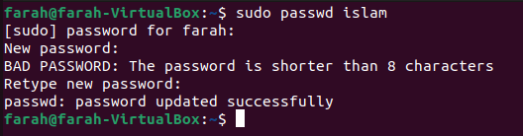

Q7:



Q8:

Q9:



Q10:

